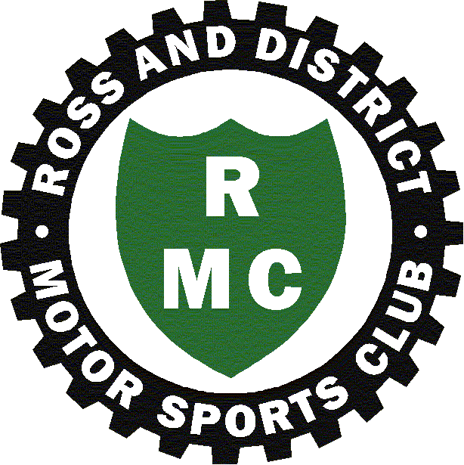

The **PETE FEAR**

Sporting Trial

**Sunday, 22nd September, 2024**

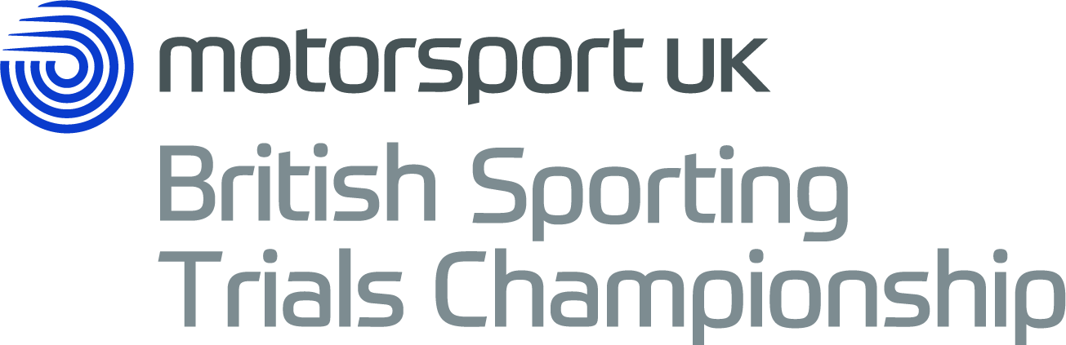

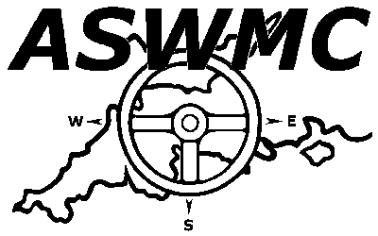

**A QUALIFYING ROUND OF THE:**

Motorsport UK 2024 British Sporting Car Trials Championship

2024 BTRDA® Sporting Trials Championship

2024 BTRDA® Allrounders Championship

2024 ASWMC Sporting Trials Championship



**ROSS – ON – WYE, HEREFORDSHIRE**

**Pete Fear Sporting Car Trial 2024 Supplementary Regulations**

Ross & District Motor Sports Ltd will hold a Clubmans Permit Sporting Trial at Pinford Farm near Linton. Thanks to the help of landowner Chris Goulding we have a paddock area for competitors which is just off the road and with plenty of flat parking. This will mean that there is a short drive of about 5 minutes across his fields to the sections, and marshals are able to park in their own area just above the hills.

We will as usual be using electronic entries and payments (**preferably by BACS please**) which are much easier for the organisers to deal with. Please also remember that Covid is still around so please act responsibly and respect other people’s space.

1. Ross & District Motor Sports Ltd. will organise a Clubman Sporting Car Trial on Sunday 22nd September 2024 at Pinford Farm, Linton, Herefordshire, OS map reference SO653242. Nearest post code is HR9 7PR (but please note this is NOTprecisely the trial site).
2. The meeting will be governed by the General Regulations of Motorsport UK (incorporating the provisions of the International Sporting Code of the FIA), by these Supplementary Regulations, and by any other written instructions that the organising club may issue for this event.
3. Motorsport UK permit number is : Applied for
4. The event is open to all fully elected members of the organising club, BTRDA, 750 MC, Kentish Border Car Club, Midlands Trials Car Club, Northern Phoenix Trials Car Club, Camel Vale MC, Launceston & North Cornwall MC and Bristol MC. The event is also open to registered contenders in the Motorsport UK British Sporting Trial Championship and the ASWMC Championship. Entry forms must be retrieved from the Ross & District Motor Sports Club website and completed online.
5. All drivers and passengers must produce a valid club membership card at signing-on, together with a minimum of an RS Clubman licence issued by Motorsport UK for 2024. Only those crew members signed-on may be a driver or passenger in any car.
6. The trial is a qualifying round of the following : 2024 Motorsport UK Sporting Trials Championship (Permit no.CH2024/T001, 2024 BTRDA Sporting Trials Championship (permit not required), 2024 ASWMC Sporting Trials Championship & 2024 BTRDA Allrounders Championship.
7. The event will be held at Pinford Farm, Linton, Herefordshire as detailed in 1) above. Public roads will not be used to link sections. There will be 8 sections on private land and 3 rounds of hills (weather permitting). The entry will be split into groups starting on different hills to enable the programme to be completed. Signing-on and scrutineering will commence at 08.30 and the competition will begin at 10.30. There will be a driver’s briefing at 10.15. Any competitor not scrutineered and signed-on by 10.10 may be excluded.
8. All cars must comply with the Motorsport UK Technical Regulations and the Motorsport UK National Trials Car Formula or the 750MC Trials Car Formula as applicable. Permissible tyres on the driving wheels to earn championship points areVredestein T-Trac 2, Nankang CX668, Maxxis MA-510N or Yokohama GT Classic Y350H. Entrants using another tyre listed by MSUK will not be included in the results.
9. All cars except Clubman and Post Historic must have passed the Sharp Differential Test and have the Motorsport UK seal attached and intact. Only those cars on the accepted list will be eligible for the BTRDA and Motorsport UK Championship classes. Clubman and Post Historic entries will not be included in overall classification.
10. The event will be divided into the following classes : **Red Independent, Red Live, Blue Independent, Blue Live** and **Rookies as per existing BTRDA class qualification. There will also be a Clubman class for those cars not eligible for BTRDA, and Post Historic Class.**
11. Double-drives will be permitted so long as the secretary is made aware before the entry closing date.
12. Awards will be presented as follows :

First driver overall – the Pinford Trial Trophy plus an award

To the passenger of the above – an award

Best Red Independent driver – an award

Best Red Live driver – an award

Best Blue Independent driver – an award

Best Blue Live driver – an award

Best Rookie driver – an award

Best Clubman driver – an award

Best Post Historic driver – an award

Best placed driver who was a Ross & District Motor Club member before 1st July 2024 – an award. All class awards are subject to a minimum of 3 class entries being received.

1. Entries open upon receipt of these regulations and close finally on Wednesday 18th September. The entry fee is £50 up to and including Sunday 15h September and then £60 until final closing date, so please enter in plenty of time. **All entries MUST be made on-line using the link on the Pete Fear ST page of the Ross & District Motor Sports Club website :**

<http://www.rossmotorsports.co.uk/events/pete-fear-sporting-trial-5/> **and received by the dates given above, and payment made by BACS (preferred) to Ross & District Motor Sports Ltd at Santander Bank, sort code : 09-01-29, and account number : 34908761, or by PayPal using the link on the Club website or the e-address** [**ross.motorclub@outlook.com**](mailto:ross.motorclub@outlook.com) **. Please mark your payment reference PFT followed by the first 3 letters of your first name and surname (for example PFTalabak for Alan Baker) No paper entries or cheques will be accepted, nor anything on the day**. Entries will only be accepted on receipt of a completed on-line entry form and **BACS** or PayPal payment. Any withdrawal of entries can only be made by email to the entries secretary. Entries withdrawn before the closing date will be entitled to a full refund. Withdrawals after then will be at the Club's discretion.

1. The event secretary is : Hilary Carrott

**email :** [**the_carrott@hotmail.co.uk**](mailto:the_carrott@hotmail.co.uk) **Please note the underscore!**

mobile : 07871 043367

1. The maximum entry for the meeting is 50 and the minimum is 20. Should the minimum not be reached then the organisers reserve the right to cancel the event.
2. Other officials :

Clerk of the Course : Alan Baker

Club Stewards : TBA

Scrutineers : TBA

Chief Marshal : TBA

Results : Hilary Carrott

In line with Motorsport UK recommendations the Club have a Club Safeguarding Officer, Carol Morgan, who may be in attendance or can be contacted on 07882 665989. Our Data Protection Privacy Notice is on our Club website.

1. Provisional results will be announced as soon as possible after the last car has finished, followed by the presentation of awards.
2. Any protests must be lodged in accordance with C5.1 to C5.7. Awards will then be presented after any protest period.
3. Competitors will be identified by numbers provided by the organisers and should remain visible for the duration of the event. These numbers, together with competitor’s score cards (for personal use only) will be issued at signing-on.
4. Scoring and penalties will be as per Motorsport UK General Regulation T7.5. Scoring on the day will be by **marshal’s master sheets only**, although competitors may record their own scores as a personal reference. If you wish to keep your own score remember to bring a pencil! Competition numbers and score cards will be supplied by the organisers.
5. All other General Regulations of Motorsport UK will apply as written.
6. The use of motorcycles, quad bikes etc. is restricted to authorised persons only. As this is a working farm we would prefer you not to bring any dogs. Any dogs present must be kept on a lead at all times.
7. No person may drive a competing car on the site except the named driver.
8. All cars entered must be fitted with an effective silencer.
9. Portable toilets will be provided at both the competitor’s paddock and at the location of the competitive hills.
10. There will be a Paramedic on site during the event.
11. Final Instructions will be emailed out with maps to the venue.

-----------------------------------------------

Ross and District Motor Sport Ltd. and the organising team are pleased to acknowledge, with thanks, the kind assistance of :

Landowner Mr Chris Goulding and his family.

The Paramedic in attendance, Tony Morgan (or one of his team).

All the marshals and officials for their time and effort in making the event possible.